T: 01403 752 002
E: valmorahgundogs@gmail.com

Gundog | Obedience | Puppy | Residential

Valmorah Gundogs Training Grounds

By kind permission of Care Ashore

Address:
Springbok Estate
Dunsfold Road
Alfold
Cranleigh
Surrey
GU6 8EX

From either Horsham or Guildford –

- From the A281 (either direction) please turn off at the cross roads of :
A281 / Loxwood Road / Dunsfold Road
(This is the cross roads near to the Alfold Mower centre.)
- Continue along the Dunsfold Road, following the sharp turn to the left.
- Continue along this road for about half a mile, there will be a sign on your left for “Care Ashore”.
- Turn left here, and follow the road, over the speed bumps, passing houses on your left and a pond on your right.
- Please follow signs to the Campsite / Glamping.
- Continue along this track and take the first right turn which looks like half a turning circle. it will be signed as "Farm Business Units"
- You will see fields directly ahead past the workshop. Continue and stop at the entrance of the field with the open gate and metal structure.

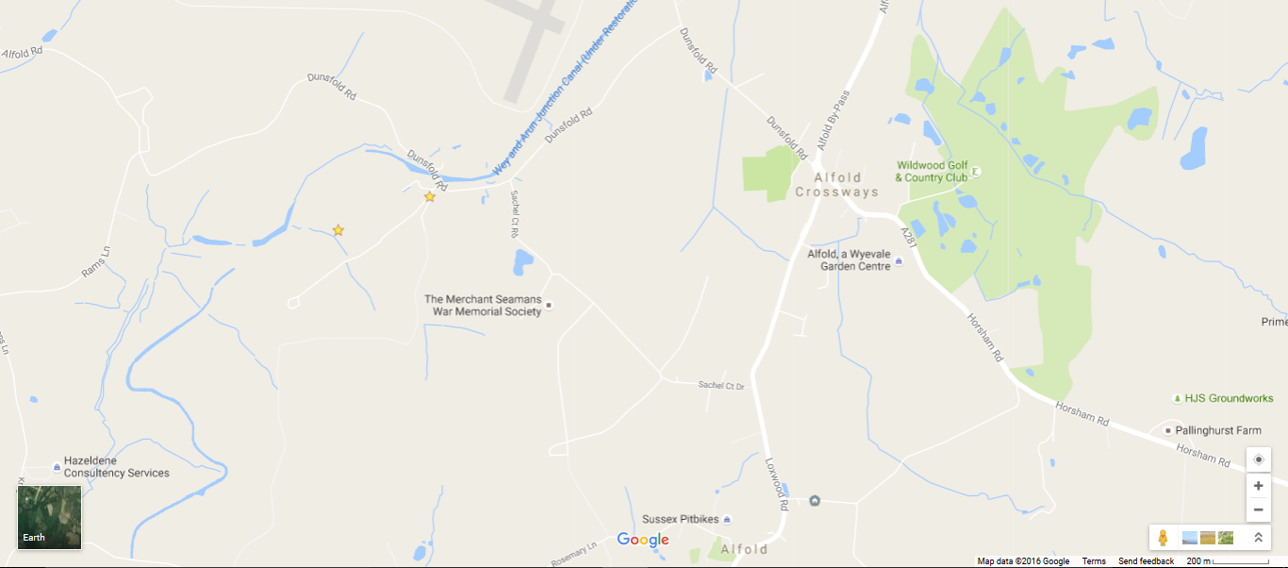
We are here!

